# File Types, Filename Extensions, File Association

**Example = myhomework.docx is "clearly" a Word document because it has .docx as the extension.**

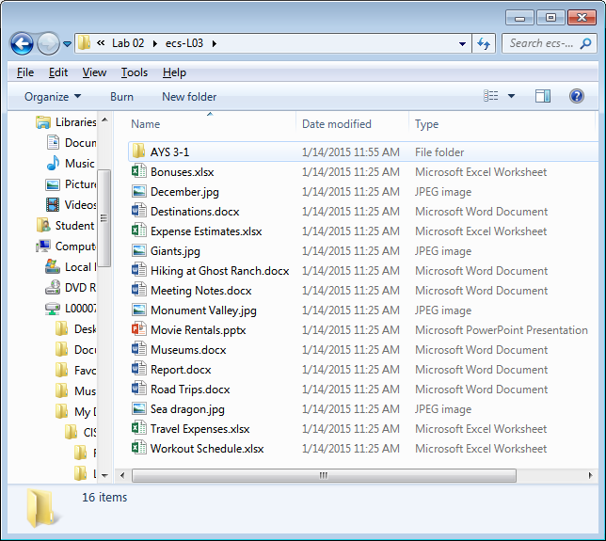

Files have stuff at the end of the filename called an Extension. It's the part after the last period. (Caution - you may not see it if you haven't "fixed" the very bad, no good, default file settings. See the [Fix/setup file windows on your home computer Page](https://classes.lanecc.edu/mod/page/view.php?id=1085177) to fix this.)

Every file has a file type. It tells you what kind of internal file format the file has. Files are associated with the program that created them and/or a program that can open/edit/read them.

When a file is associated with a program it gets an icon that obviously goes with the program. Like a big blue W for a Word document. This means you can just double-click the file and it will open the file IN the associated program. You will also see the name of the program in the Type column of a file window.

File association happens when a program is installed. As part of the installation, the program claims a group of file extensions and registers that claim in The Registry. (The Registry is a huge database in the guts of Windows that tracks stuff for/from programs.)

For example:

.docx = Word 2007/10/13

.doc = Word 1997/2000/02/03

.txt = plain text, non-proprietary, can be read by anything

.rtf = rich text format, non-proprietary, can be read by almost anything

.wps = MSWordpad, very proprietary, cannot be read by MSWord, cannot be read by most things   
DO NOT save homework as .wps! If you have only Wordpad, save as .rtf or .docx (or the world will end).

.mp3 = a song, hence the name MP3 Player

.avi = a video

.xlsx or .xls = an Excel spreadsheet

.pptx or .ppt = a Powerpoint presentation

.jpg or .gif or .png = a picture/graphic

.html = a web page

.pdf = an Adobe Acrobat file

.exe and .com = program files

.lnk = shortcut

.pif = old school shortcut

NOTE: .net .com .org .edu look like filename extensions but they are Internet things. They are TLD (Top Level Domain Names). part of a URL aka web address.

.odt = OpenOffice/LibreOffice word processor file

.ods = OpenOffice/LibreOffice spreadsheet file

.odp = OpenOffice/LibreOffice presentation file

OpenOffice and LibreOffice users will want to change the default save options to save as Microsoft file types because Microsoft owns the universe and your life will be easier if you just comply. smile